St. Beatrice da Silva Meneses

Lady-in-waiting for Queen Isabel of Portugal
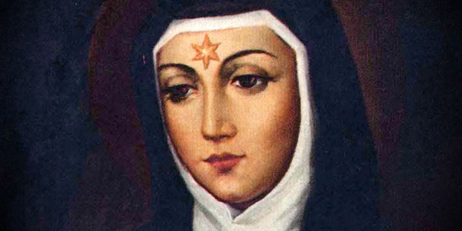

Foundress of the Conceptionist Nuns: 1424-1492
Her life
+ Beatrice was born in Campo Major, Spain, and was the daughter of the Count of Viana. Her brother was Blessed Amadeus of Portugal.
+ As a young woman, Beatrice served as lady-in-waiting to Princess—and later Queen—Isabel of Portugal. Although they were close friends, Beatrice was considered very beautiful and the queen grew jealous. In an outburst, she ordered Beatrice to be imprisoned in a tiny cell.
+ During her time as a prisoner, Beatrice had a vision of the Virgin Mary during which she was told to found a new community in Mary’s honor.
+ Beatrice eventually left life at court to become a Cistercian nun (some sources say she was a Dominican nun). Around 1484, Beatrice left the Cistercians and founded a new religious community: the Congregation of the Immaculate Conception of the Blessed Virgin Mary (the Conceptionist Nuns).
+ With the help of Queen Isabel, Beatrice built a new house for the nuns and served as abbess until her death on August 17, 1492.
+ Devotion to Saint Beatrice was confirmed by Pope Pius XI in 1926 and she was formally canonized by Blessed Pope Paul VI in 1976.
+ In 1501, Pope Alexander VI placed the Conceptionist nuns under the Rule of St. Clare, uniting them with the Franciscans. In 1511 and 1516, the order was given its own rule of life.
Spiritual bonus
Saint Beatrice’s brother, Blessed Amadeus, was a Franciscan friar who founded a short-lived reform movement of the Franciscan Order, known as they Amadeistene. Honored as a mystic and prophet, his memory is celebrated on August 10.
Quote
“I despised the kingdom of the world and all worldly finery for love of my Lord, Jesus Christ, whom I have seen, whom I have loved, in whom I have believed, in whom has been my delight.”—Entrance Antiphon for the Mass of the Common of a Nun in the Roman Missal
Prayer
O God, who called your handmaid blessed Beatrice to seek you before all else, grant that, serving you, through her example and intercession, with a pure and humble heart, we may come at last to your eternal glory. Through our Lord Jesus Christ, your Son, who lives and reigns with you in the unity of the Holy Spirit, one God, for ever and ever. Amen.

