Singapore Turns Sewage into Clean, Drinkable Water, Meeting 40% of Demand August 10, 2021 1:26 AM Agence France-Presse
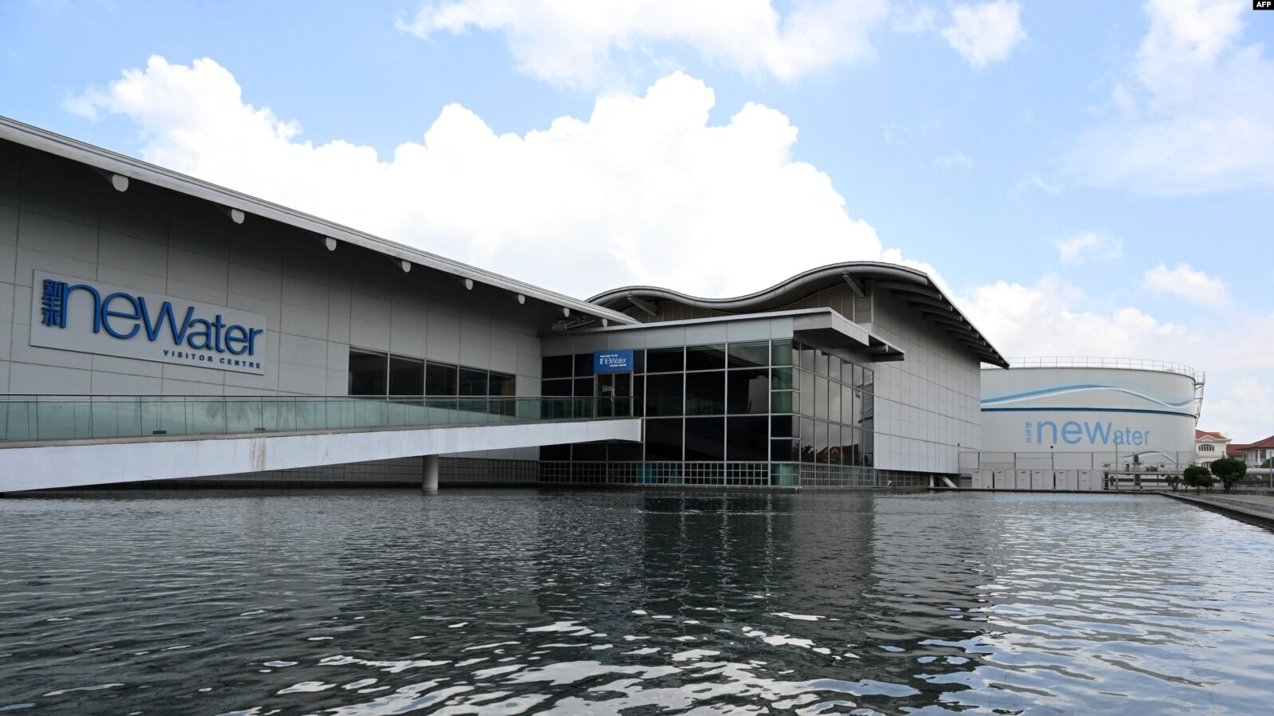
Giant pumps whir deep underground at a plant in Singapore that helps transform sewage into water so clean people can drink it while reducing ocean pollution. The tiny island nation has little in the way of natural water sources and has long had to rely principally on supplies from neighboring Malaysia. To boost self-sufficiency, the government has developed an advanced system for treating sewage involving a network of tunnels and high-tech plants. Recycled wastewater can now meet 40% of Singapore's water demand, a figure that is expected to rise to 55% by 2060, according to the country's water agency. While most is used for industrial purposes, some of it is added to drinking water supplies in reservoirs in the city-state of 5.7 million people. And the system helps reduce maritime pollution, as only a small amount of the treated water is discharged into the sea. This is a contrast to most other countries: 80% of the world's wastewater flows back into the ecosystem without being treated or reused, according to United Nations estimates. “Singapore lacks natural resources, and it is limited in space, which is why we are always looking for ways to explore water sources and stretch our water supply,” Low Pei Chin, chief engineer of the Public Utilities Board's water reclamation department, told AFP. One key strategy is to “collect every drop” and “reuse endlessly,” she added. This is in addition to the city-state's other main approaches to securing water supplies: importing it, using reservoirs and desalinating seawater. At the heart of the recycling system is the high-tech Changi Water Reclamation Plant on the city's eastern coast. Parts of the facility in land-scarce Singapore are underground, some as deep as 25 stories, and it is fed by wastewater that flows through a massive, 48-kilometer (30-mile) tunnel, linked to sewers. The site houses a maze of steel pipes, tubes, tanks, filtration systems and other machinery, and can treat up to 900 million liters (237 million U.S. gallons) of wastewater a day — enough to fill an Olympic-sized swimming pool every 24 hours for a year. In one building, a network of ventilators has been installed to keep the air smelling fresh, although a putrid odor still hangs in the air. Sewage that arrives at the plant undergoes an initial filtering process before powerful pumps send it flowing to facilities above ground for further treatment. There, the treated water is further cleansed, with impurities like bacteria and viruses removed through advanced filtration processes and disinfected with ultraviolet rays. The end product, dubbed NEWater, is mainly used in microchip manufacturing plants, which are ubiquitous in the city-state and require high-quality water, and for cooling systems in buildings. But it also helps boost drinking water supplies. During the dry season, it is sent to top up several man-made reservoirs and, following further treatment, flows to people's taps. Singapore is expanding its recycling system. It will add an extra underground tunnel and a major water reclamation plant to serve the western half of the island, which should be completed by 2025. Singapore will have spent Sg$10 billion (U.S. $7.4 billion) on upgrading its water treatment infrastructure by the time the expansion is finished. One impetus to seek greater self-sufficiency are the city-state's historically fractious relations with Malaysia, its key water source. The neighbors have had stormy ties since Malaysia ejected Singapore from a short-lived union in 1965, and they have in the past had disagreements over water supplies. Stefan Wuertz, a professor of environmental engineering at Singapore's Nanyang Technological University, stressed the importance for other countries to treat wastewater more effectively, warning of serious long-term impacts otherwise. “There is a limited amount of water on the planet,” he told AFP. “If we were to keep polluting the freshwater, at some stage we would reach the point where … treatment becomes extremely expensive.”

Water shortages and rationing in Singapore
Singapore is considered to be one of the most water-stressed countries in the world. It is heavily dependent on rainfall due to the lack of natural water resources, and limited land is available for water storage facilities.¹ Prolonged dry spells cause or threaten to cause water shortages, the most recent being in 1990.² Under severe conditions, water rationing was implemented; the last occasion was in 1963–64 though there have been mock water rationing exercises since then.³
Water shortages in pre-independence Singapore
Providing an adequate supply of water was a challenge during much of Singapore’s pre-independence history. Despite the completion of the Impounding Reservoir (later renamed MacRitchie Reservoir) in 1867 and its subsequent expansion, there was not enough supply to meet the increasing demand.⁴ The droughts of 1885, 1895 and 1902 put such severe pressure on water stocks that the municipal authorities restricted the water supply to as little as two hours a day.⁵
To meet growing demand, two more impounding reservoirs were built in Singapore and water schemes were developed in Johor to provide an additional source of supply.⁶ Still, there continued to be anxiety over water shortages during dry spells.⁷ The government began looking into developing new water sources in Johor in the 1940s, but their plans were interrupted by the Second World War. After the Japanese Occupation, Singapore faced another water crisis as consumption rose beyond the capacity of existing resources by 1946. To alleviate the situation, the government expanded the capacity of existing facilities and restarted efforts to import more water.⁸
Despite the progressive completion of these projects, Singapore’s water supply remained barely sufficient to meet consumption needs.⁹ Recognising the urgent need to develop new water sources, the government began developing major water schemes in Johor in the late 1950s.¹⁰ However, before these projects could be completed, severe droughts hit Singapore and Johor, forcing the government to impose water rationing in 1961 and 1963.¹¹ Through radio broadcasts and newspapers, the public was also constantly reminded to save water and reduce wastage.¹²
Water rationing in 1961 and 1963
For the purpose of water rationing, Singapore was divided into seven zones. When water rationing was imposed on 1 September 1961, the water supply was cut off at fixed times every day, with each zone receiving no supply for six hours four times a week based on a predetermined schedule.¹³ With rainfall in January 1962, water rationing was lifted on 26 January.¹⁴ However, daily water rationing was imposed again on 23 April 1963, with the supply in each zone cut off for six hours four times a week.¹⁵ Seven days later, more severe restrictions were introduced, with the water supply cut off for 12 hours three times a week.¹⁶ This lasted almost nine months until the Public Utilities Board (PUB), which had been formed in May 1963, eased the restrictions in January 1964 after sustained heavy rainfall. Water rationing was finally lifted on 28 February 1964.¹⁷
Water situation in post-independence Singapore
The water supply from Johor was significantly increased with the completion of two new waterworks in 1965 and 1968.¹⁸ However, another dry spell in early 1971 led to warnings of water rationing again.¹⁹ The PUB appealed to the public to conserve water and promoted water-saving ideas such as bathing no more than once a day, putting a brick in the toilet cistern, and using buckets instead of hoses when washing vehicles. Posters were also put up in public places. Appeals were sent directly to consumers with high water usage, while all PUB bills incorporated the reminder, “Water is precious. Don’t waste it.”²⁰ In addition, the PUB took legal action against those caught wasting water, an offence that carried a maximum fine of S$500.²¹ The campaign, now known as Singapore’s first “Water is Precious” campaign, succeeded in reducing water consumption, thus staving off water rationing.²² Since then, public education programmes have been a key component of Singapore’s water demand strategy.²³
Author
Centre for Liveable Cities
S'pore's fourth desalination plant, which can treat both sea and reservoir water, officially opens

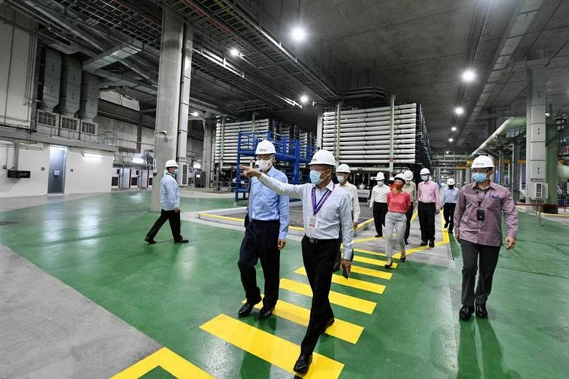
SINGAPORE - Water security in Singapore has been boosted with the opening of the country's fourth desalination plant.
The Keppel Marina East Desalination Plant is the only one in the Republic capable of treating both sea and reservoir water, and is part of efforts to ensure that taps never go dry, rain or shine. The facility, which has been operational since last June, was officially opened on Thursday (Feb 4) by Prime Minister Lee Hsien Loong. National water agency PUB chief executive Ng Joo Hee said at the event that desalination - or the conversion of sea water into drinkable water - is one of Singapore's four national taps. "Unlike the other three taps - imported water, rainfall and recycled water - (the sea) is a practically limitless resource," he said. The plant can treat about 30 million gallons a day (mgd), or up to 7 per cent of Singapore's daily water needs of about 430mgd. Currently, the lion's share of water in Singapore is imported from Malaysia's Johor River. However, changing weather patterns due to climate change could make water sources replenished by rainfall less resilient. To ensure water security, Singapore is looking to desalination as a weather-proof source of water. It is also seeking to maximise the use of the resource by recycling every drop to form Newater. With water consumption set to double by 2060, PUB had earlier said that the plan is for Newater and desalination to meet up to 85 per cent of Singapore's future water demand. On Thursday, Mr Ng said: "The availability of desalination makes Singapore's water supply immensely resilient. And the (new plant) coming online further strengthens Singapore's water security." The 2.8 ha facility - about twice the size of a football field - can draw water from the sea during periods of dry weather, or treat water from the Marina Reservoir during periods with heavy rain. It is the first large-scale desalination plant with both these features, and was built following years of testing and research, including a 2007 test of dual-mode desalination at a 1 mgd pilot plant in Pasir Ris.

Multi-use plant

Mr Chew Chee Keong, PUB's director for water supply (plants), told The Straits Times that the facility, located right by the coast and next to the Marina Reservoir, is in a good position to harness both sources of water. He added: "With climate change, we can expect more weather uncertainty - we are likely to experience more intense rainfall and more severe drought. (The plant's) dual mode function affords PUB greater operational flexibility to respond to the vagaries of weather, thereby strengthening Singapore's water supply resilience." Mr Tan Boon Leng, managing director for environmental infrastructure at Keppel Infrastructure, the plant's builder and operator, explained that before it was built, Marina Barrage had to pump out excess water into the sea during periods of heavy rainfall, which was "a waste of the rainwater that we captured". He added: "The key feature here is really to make better use of the investments that we have."
Dr Cecilia Tortajada, an adjunct senior research fellow at the Lee Kuan Yew School of Public Policy's Institute of Water Policy, told The Straits Times that other than boosting water security for the country, the new plant can also help Singapore use its resources more efficiently. "Energy use is related to how saline water is. During the times freshwater is used, the plant will use much less energy," said Dr Tortajada, who added that the dual function also makes the plant an efficient use of land. While on reservoir mode, the plant uses about a third of the energy required for it to operate while on seawater mode, according to PUB's Mr Chew.
Dr Tortajada added that despite the financial cost of desalination, it is imperative for Singapore to build up such capabilities to deal with the changing climatic and geopolitical situation. "Costs of desalination are never uni-dimensional. They are not economic only, but also social and environmental... To see the issue of cost within a broader perspective, one has to also consider what would be the social costs for Singapore of not being able to provide clean water," she said. Besides being the first dual-mode desalination plant in Singapore, the Keppel Marina East facility is also the first to feature a recreational space, accessible to the public via the Eastern Coastal Loop of the Park Connector Network that bridges East Coast Park and Gardens by the Bay East. The upcoming Founders' Memorial MRT Station, slated to open in 2025, will be about 1km away on foot. Pointing to its open green rooftop space spanning about 20,000 sq m, Tanjong Rhu resident Tom Stephens said the plant's design is reminiscent of the Marina Barrage. The 40-year-old, who works in banking, added that he often takes walks around the plant with his nine-month-old toddler. "It's beautiful in the evenings, especially with the view of the city skyline," he said. The plant is the second developed and operated by Keppel under the PUB's Design, Build, Own and Operate arrangement, and will be operated by its subsidiary Marina East Water for 25 years from 2020 to 2045. Its first, the Keppel Seghers Ulu Pandan Newater Plant, commenced operations in 2007. In winning a 2016 open tender, it was agreed that Keppel would supply water at a first-year price of $1.07867 per cubic m to the PUB

Other desalination plants
Meanwhile, PUB said that the fifth desalination plant, on Jurong Island, which was slated to open in 2020, has been delayed due to the Covid-19 pandemic, although it is expected to be up and running by the first half of this year. As for the Tuas South Desalination plant - which PUB took over from embattled water treatment firm Hyflux in May 2019 - it is capable of producing drinking water even while repairs to address operational issues are ongoing, said Minister for Sustainability and the Environment Grace Fu said in a written reply to Mr Gerald Giam, an MP for Aljunied GRC, on Monday (Feb 1). She said: "The repairs, which included the replacement of ultra-filtration and reverse osmosis membranes, cost around $80 million in total and are on track for completion in mid-2021."

